Lab 11

By Hoda Malak
Dashboard
Q1: What is the benefit of using dashboard?
Dashboards in Tableau have several benefits. First, they allow users to easily visualize and analyze data from multiple sources in one place, making it easier to track performance and gain insights. Second, Tableau Dashboards use text, graphic objects, visualizations, and other elements to give you a complete picture of your data. Dashboards are customizable, so users can create panels that display the most relevant metrics for their needs. These features make dashboards very informative.
Q2: Create a snapshot of the created dashboard and insert it into your document.

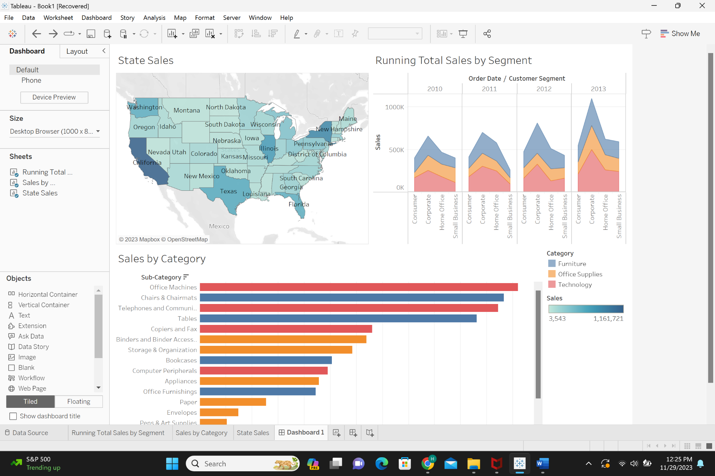

Q3: Create a snapshot of the highlighted information related to “Technology” dashboard and insert it into your document.
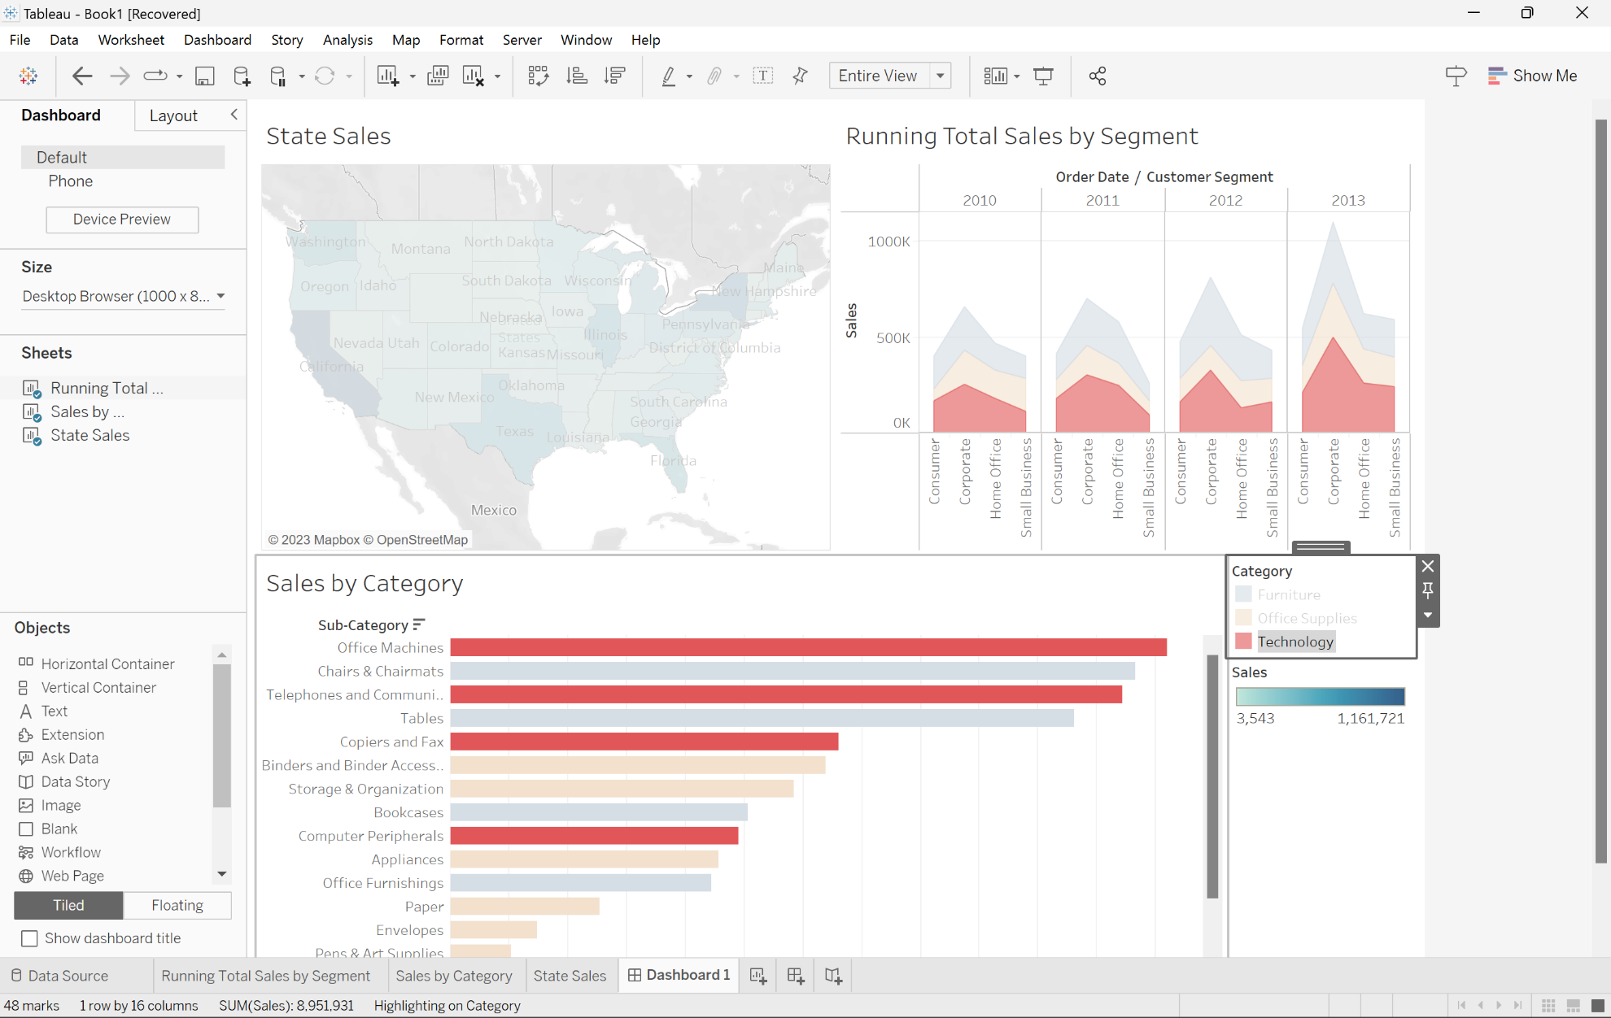
Q4: Create a snapshot of the highlighted information related to “Technology” applied to all worksheets within dashboard and insert it into your document.
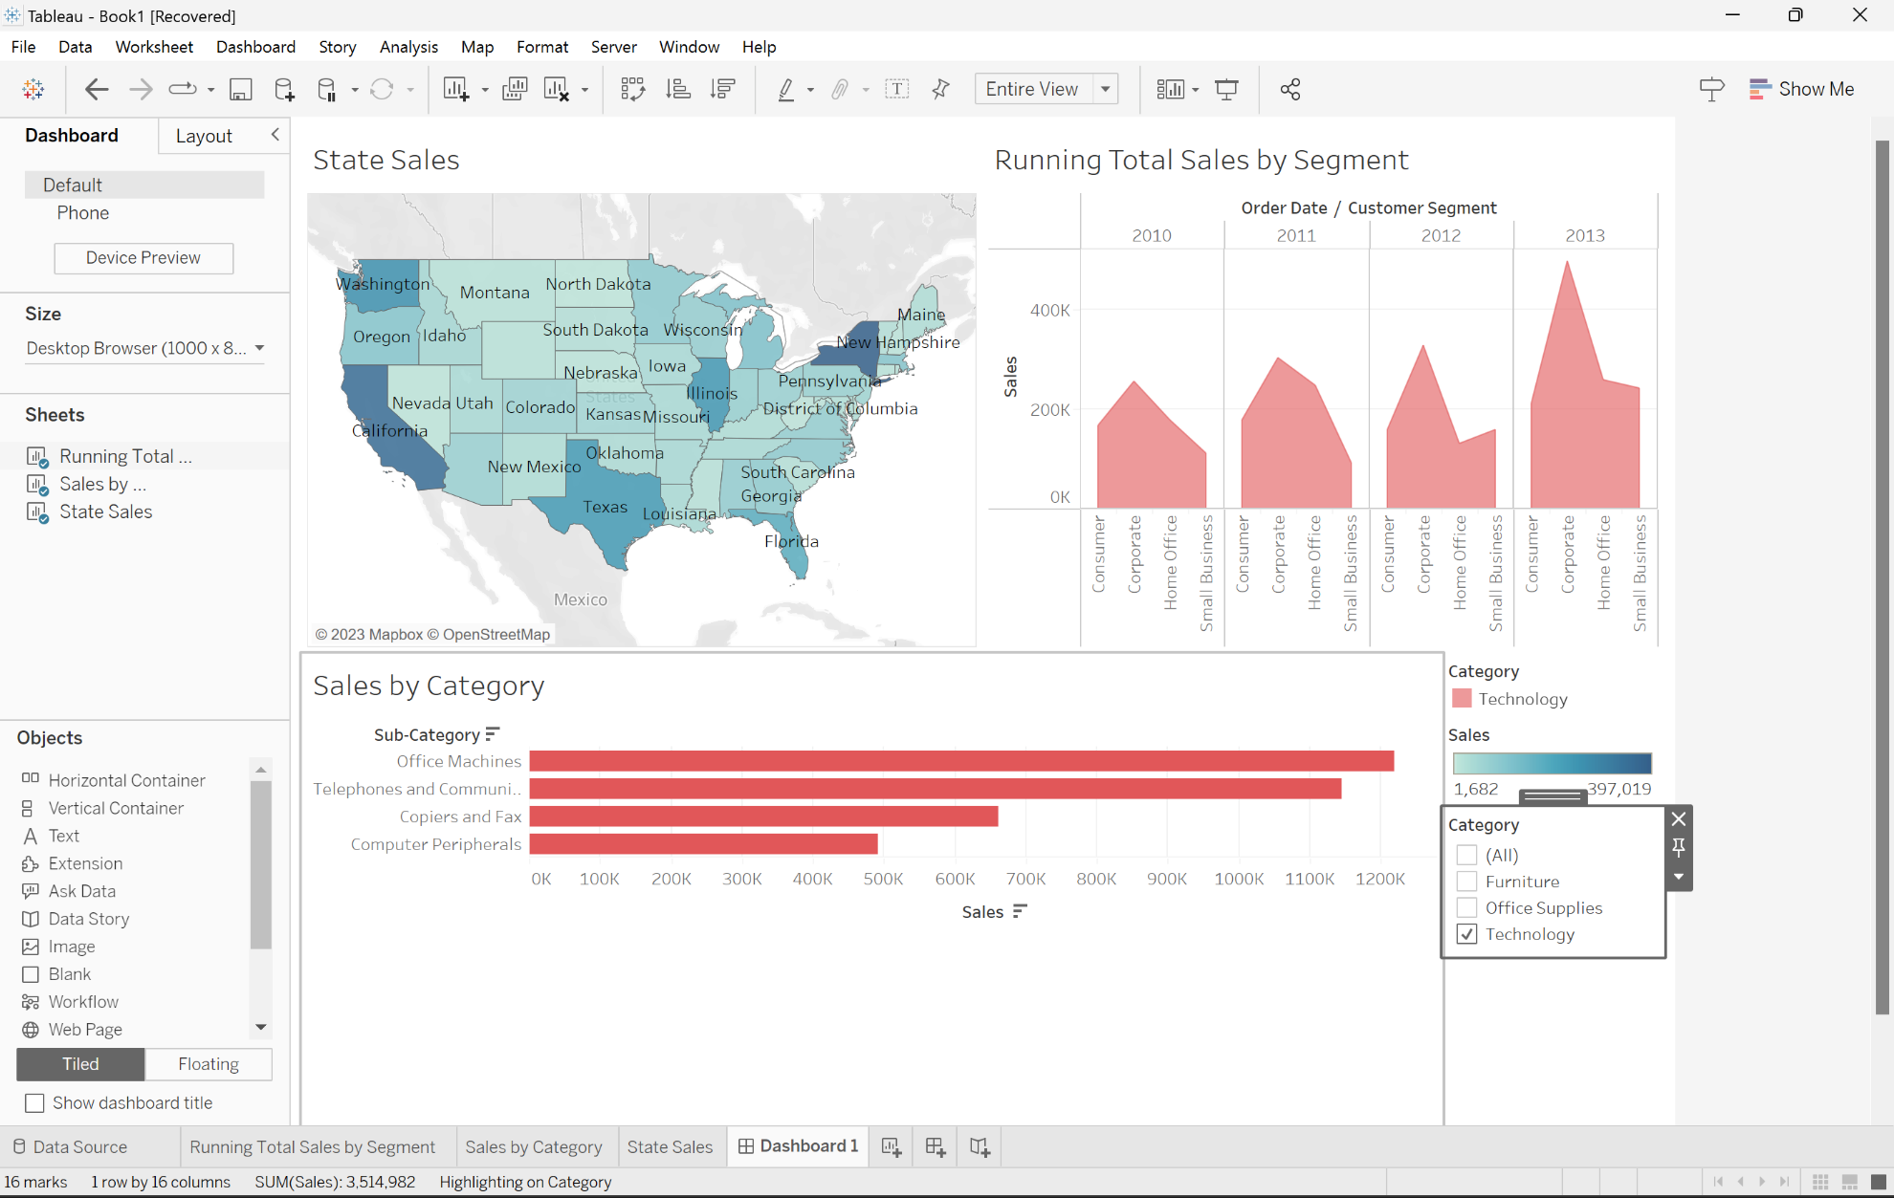
Q5: Create a snapshot of the final created dashboard containing a picture, text, and webpage and insert it into your document.
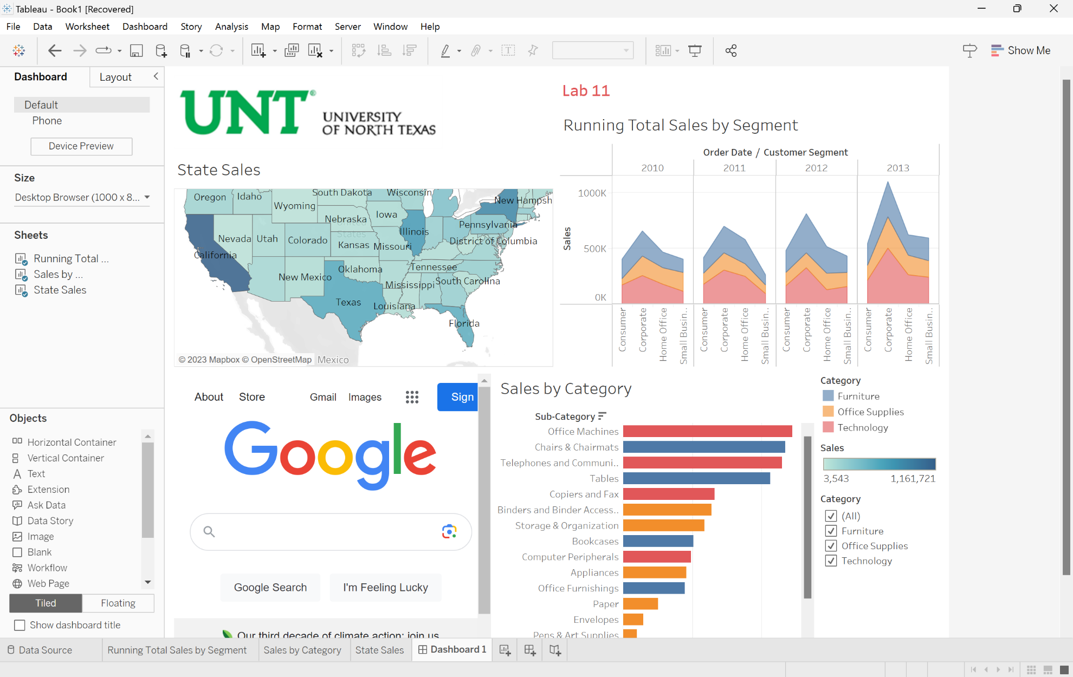
Story Point
Q6: Create a snapshot of the created dashboard and insert it into your document.
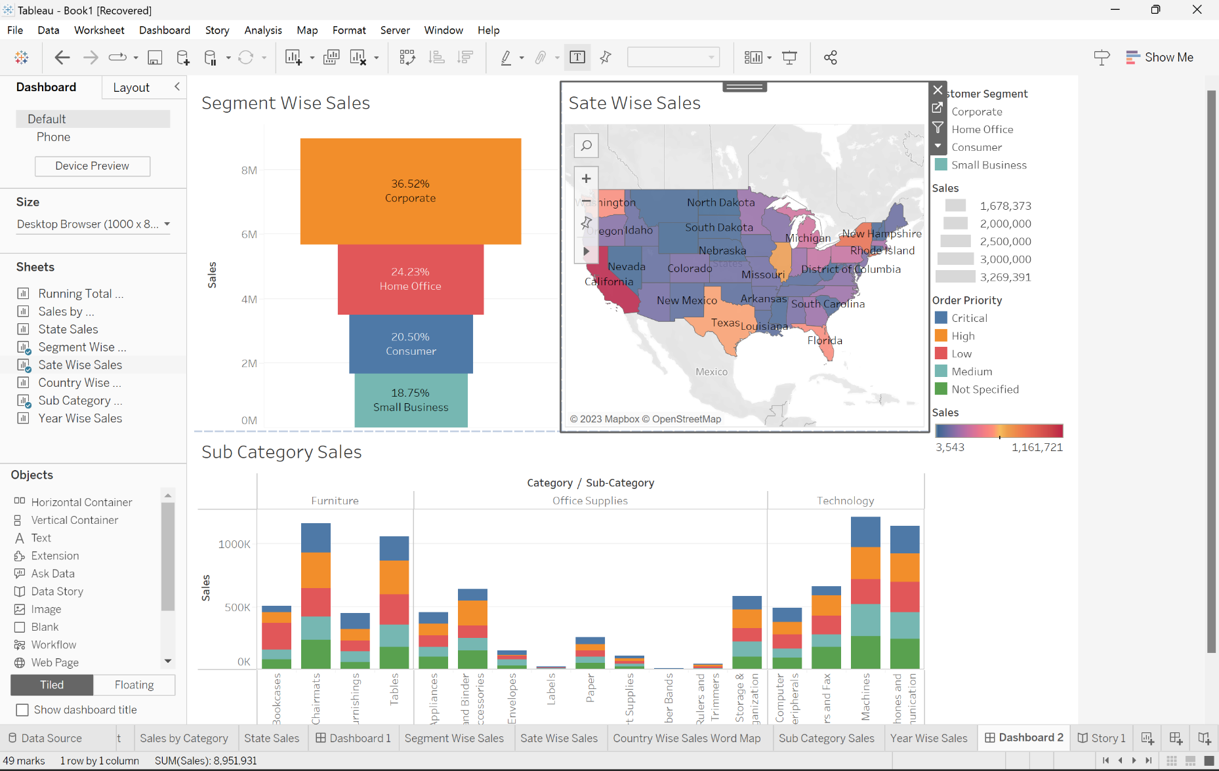
Q7: Click on one of the sheets added and create a snapshot of the “Story1” and insert it into your document.
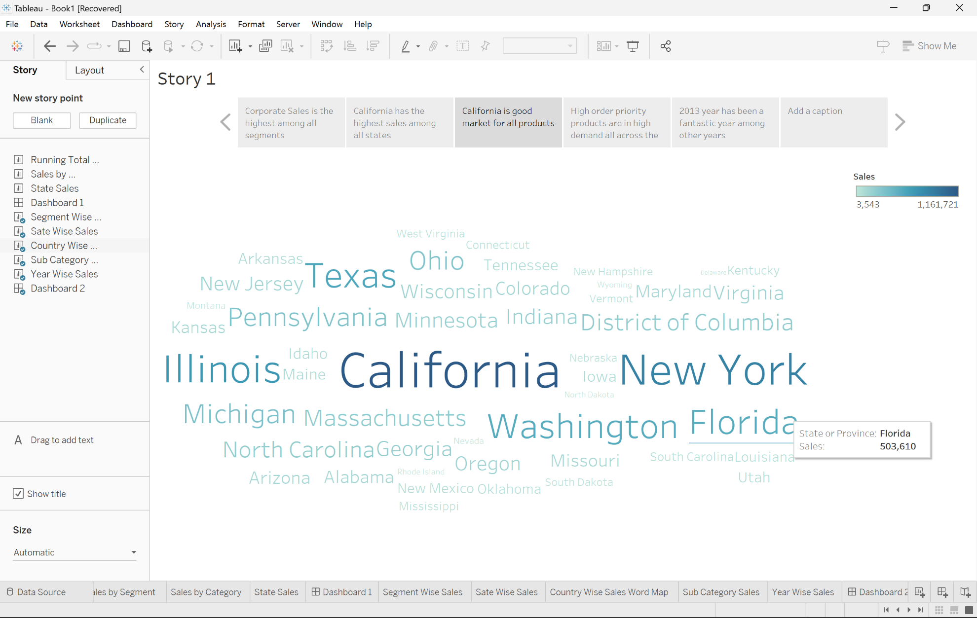
Q8: Create a dashboard from “ABC” dataset and take a snapshot of the created dashboard and insert it into your document.


